**FINOLEX ACADEMY OF MANAGEMENT AND TECHNOLOGY, RATNAGIRI**

**DEPARTMENT OF MCA**

**PRACTICAL NO. 03**

**Database Programming in ASP.NET**

**Que.1. Design an ASP.NET web Applications using Connected Database architecture to add, update, delete and search customer information from database table. Consider following schema for customer_info table customer_info(cid primary key, cname, cadd)**

**Ans:**

* **Code –**

**WF.ConCustomer.aspx**

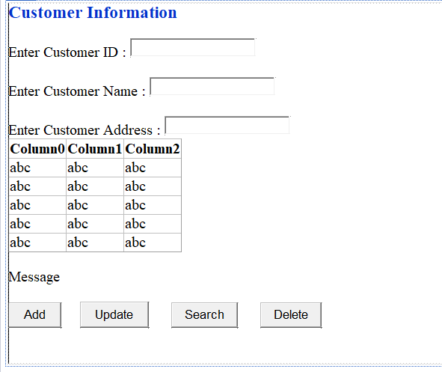

<%@ Page Language="C#" AutoEventWireup="true" CodeBehind="WF_ConCustomer.aspx.cs" Inherits="PracticalNo03.WF_ConCustomer" %>

<!DOCTYPE html>

<html xmlns="http://www.w3.org/1999/xhtml">

<head runat="server">

<title>Customer Information </title>

</head>

<body>

<form id="form1" runat="server">

<div style="height: 482px">

<asp:Label ID="Label1" runat="server" Font-Bold="True" Font-Size="Large" ForeColor="#0033CC" Text="Customer Information ">

</asp:Label>

<br />

<br />

<asp:Label ID="Label2" runat="server" Text="Enter Customer ID : "></asp:Label>

<asp:TextBox ID="txtCid" runat="server" Height="19px"></asp:TextBox>

<br />

<br />

<asp:Label ID="Label3" runat="server" Text="Enter Customer Name : "></asp:Label>

<asp:TextBox ID="txtCname" runat="server"></asp:TextBox>

<br />

<br />

<asp:Label ID="Label4" runat="server" Text="Enter Customer Address : "></asp:Label>

<asp:TextBox ID="txtCadd" runat="server"></asp:TextBox>

<br />

<asp:GridView ID="gvCustDetails" runat="server">

</asp:GridView>

<br />

<asp:Label ID="lblMessage" runat="server" Text="Message"></asp:Label>

<br />

<br />

<asp:Button ID="btnAdd" runat="server" Height="34px" OnClick="btnAdd_Click" Text="Add" Width="71px" />

&nbsp;&nbsp;&nbsp;&nbsp;

<asp:Button ID="btnUpdate" runat="server" Height="35px" Text="Update" Width="92px" OnClick="btnUpdate_Click" />

&nbsp;&nbsp;&nbsp;&nbsp;&nbsp;

<asp:Button ID="btnSearch" runat="server" Height="34px" Text="Search" Width="89px" OnClick="btnSearch_Click" />

&nbsp;&nbsp;&nbsp;&nbsp;&nbsp;

<asp:Button ID="btnDelete" runat="server" Height="34px" Text="Delete" Width="82px" OnClick="btnDelete_Click" />

&nbsp;&nbsp;

<br />

</div>

</form>

</body>

</html>

**WF_ConCustomer.aspx.cs**

using System;

using System.Collections.Generic;

using System.Linq;

using System.Web;

using System.Web.UI;

using System.Web.UI.WebControls;

using System.Configuration;

using System.Data;

using System.Data.SqlClient;

namespace PracticalNo03

{

public partial class WF_ConCustomer : System.Web.UI.Page

{

static string conStr = ConfigurationManager.ConnectionStrings["custConString"].ToString();

SqlConnection conn = null;

SqlCommand cmd = null;

SqlDataReader dr = null;

DataTable dt = null;

public void clearTextBox()

{

txtCid.Text = " ";

txtCname.Text = " ";

txtCadd.Text = " ";

}

public void showData()

{

try

{

cmd = new SqlCommand("SELECT * FROM cust", conn);

if (conn.State == ConnectionState.Closed)

{

conn.Open();

}

dt = new DataTable();

dr = cmd.ExecuteReader(); //actual query is fire

dt.Load(dr);

gvCustDetails.DataSource = dt;

gvCustDetails.DataBind();

}

catch (Exception ex)

{

lblMessage.Text = "Exception " + ex.Message;

}

finally //with or without exception finally block is executed

{

conn.Close();

}

}

protected void Page_Load(object sender, EventArgs e)

{

conn = new SqlConnection(conStr);

showData();

}

protected void btnAdd_Click(object sender, EventArgs e)

{

try

{

cmd = new SqlCommand("INSERT INTO cust(cid,cname,cadd) VALUES(@cid,@cnm,@cadd)", conn);

if (conn.State == ConnectionState.Closed)

{

conn.Open();

}

cmd.Parameters.AddWithValue("@cid", txtCid.Text);

cmd.Parameters.AddWithValue("@cnm", txtCname.Text);

cmd.Parameters.AddWithValue("@cadd", txtCadd.Text);

int r = cmd.ExecuteNonQuery();

if (r != 0)

{

lblMessage.Text = "Record Inserted Successfully!!";

}

else

{

lblMessage.Text = "Record Not Inserted!!";

}

}

catch (Exception ex)

{

lblMessage.Text = "Exception" + ex.Message;

}

finally

{

conn.Close();

clearTextBox();

showData();

}

}

protected void btnUpdate_Click(object sender, EventArgs e)

{

try

{

cmd = new SqlCommand("UPDATE cust SET cname=@cnm,cadd=@cad WHERE cid=@cid", conn);

if (conn.State == ConnectionState.Closed)

{

conn.Open();

}

cmd.Parameters.AddWithValue("@cid", txtCid.Text);

cmd.Parameters.AddWithValue("@cnm", txtCname.Text);

cmd.Parameters.AddWithValue("@cad", txtCadd.Text);

int r = cmd.ExecuteNonQuery();

if (r != 0)

{

lblMessage.Text = "Record Updated Sucessfully!!";

}

else

{

lblMessage.Text = "Record not updated!!";

}

}

catch (Exception ex)

{

lblMessage.Text = "Exception" + ex.Message;

}

finally

{

conn.Close();

clearTextBox();

showData();

}

}

protected void btnSearch_Click(object sender, EventArgs e)

{

try

{

cmd = new SqlCommand("SELECT * FROM cust WHERE cid=@cid", conn);

if (conn.State == ConnectionState.Closed)

{

conn.Open();

}

cmd.Parameters.AddWithValue("@cid", txtCid.Text);

SqlDataReader dr = cmd.ExecuteReader();

if (dr.HasRows)

{

gvCustDetails.DataSource = dr;

gvCustDetails.DataBind();

lblMessage.Text = "Record found!!";

}

else

{

lblMessage.Text = "Record not found!!";

}

}

catch (Exception ex)

{

lblMessage.Text = "Exception" + ex.Message;

}

finally

{

conn.Close();

}

}

protected void btnDelete_Click(object sender, EventArgs e)

{

try

{

cmd = new SqlCommand("DELETE cust WHERE cid=@cid", conn);

if (conn.State == ConnectionState.Closed)

{

conn.Open();

}

cmd.Parameters.AddWithValue("@cid", txtCid.Text);

int r = cmd.ExecuteNonQuery();

if (r != 0)

{

lblMessage.Text = "Record deleted Successfully!!";

}

else

{

lblMessage.Text = "Record not deleted!!";

}

}

catch (Exception ex)

{

lblMessage.Text = "Exception" + ex.Message;

}

finally

{

conn.Close();

clearTextBox();

showData();

}

}

}

}

* 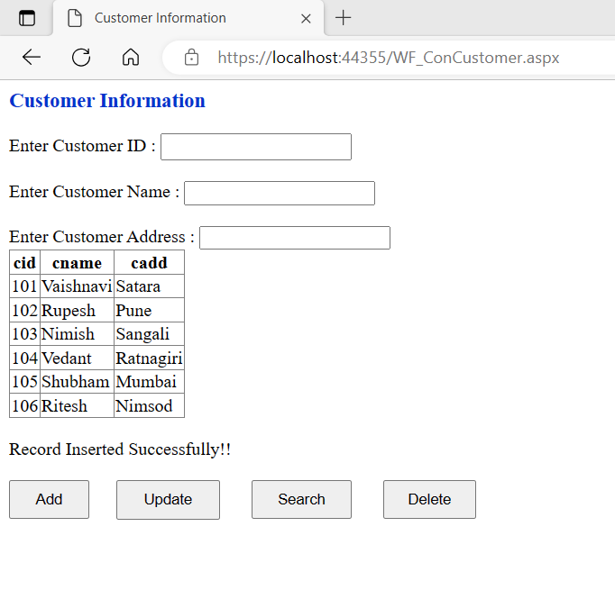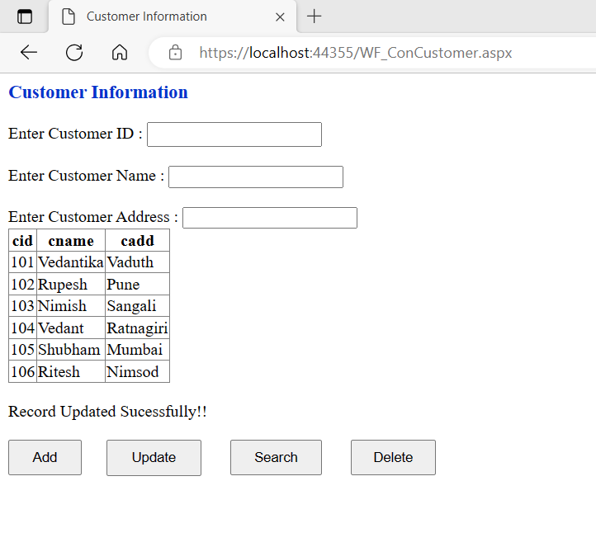**OUTPUT :**

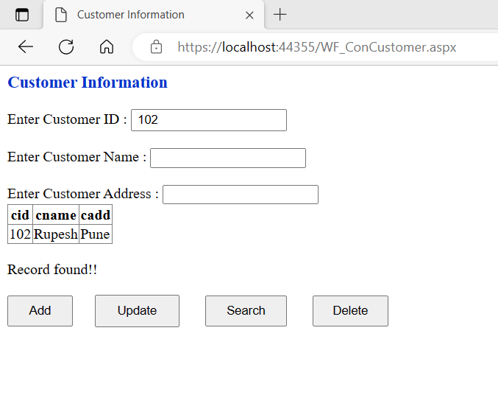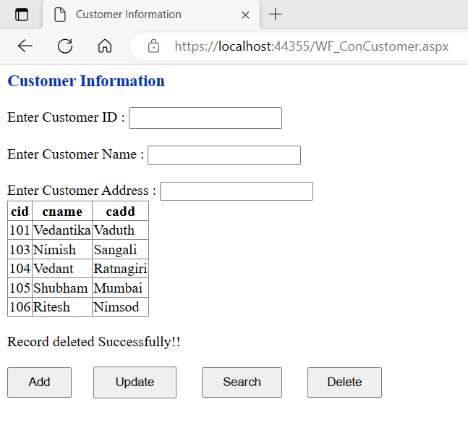

**Que.2. Design an ASP.NET web Applications using Disconnected Database architecture to to add, update,delete and search employee information from database table. Consider following schema for emp_info table emp_info(eid primary key, ename, designation, salary)**

**Ans:**

* **Code –**

**WF_EmpDisconnect.aspx**

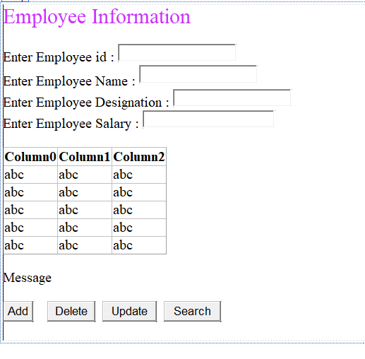

<%@ Page Language="C#" AutoEventWireup="true" CodeBehind="WF_EmpDisconnect.aspx.cs" Inherits="PracticalNo03.WF_EmpDisconnect" %>

<!DOCTYPE html>

<html xmlns="http://www.w3.org/1999/xhtml">

<head runat="server">

<title>Employee Information</title>

</head>

<body>

<form id="form1" runat="server">

<div>

<asp:Label ID="Label1" runat="server" Text="Employee Information" Font-Size="X-Large" ForeColor="#CC33FF"></asp:Label>

<br />

<br />

<asp:Label ID="Label2" runat="server" Text="Enter Employee id : "></asp:Label>

<asp:TextBox ID="txtEid" runat="server" Height="19px"></asp:TextBox>

<br />

<asp:Label ID="Label3" runat="server" Text="Enter Employee Name : "></asp:Label>

<asp:TextBox ID="txtEname" runat="server" style="margin-bottom: 3px" Height="20px"></asp:TextBox>

<br />

<asp:Label ID="Label4" runat="server" Text="Enter Employee Designation : "></asp:Label>

<asp:TextBox ID="txtDesignation" runat="server"></asp:TextBox>

<br />

<asp:Label ID="Label5" runat="server" Text="Enter Employee Salary"></asp:Label>

&nbsp;:

<asp:TextBox ID="txtSalary" runat="server" Width="179px"></asp:TextBox>

<br />

<br />

<asp:GridView ID="gvEmpDetails" runat="server">

</asp:GridView>

<br />

<asp:Label ID="lblMessage" runat="server" Text="Message"></asp:Label>

<br />

<br />

<asp:Button ID="btnAdd" runat="server" Text="Add" OnClick="btnAdd_Click" />

&nbsp;&nbsp;&nbsp;

<asp:Button ID="btnDelete" runat="server" Text="Delete" OnClick="btnDelete_Click" />

&nbsp;

<asp:Button ID="btnUpdate" runat="server" Text="Update" OnClick="btnUpdate_Click" />

&nbsp;

<asp:Button ID="btnSearch" runat="server" Text="Search" OnClick="btnSearch_Click" />

&nbsp;

<br />

<br />

</div>

</form>

</body>

</html>

**WF_EmpDisconnect.aspx.cs**

using System;

using System.Collections.Generic;

using System.Linq;

using System.Web;

using System.Web.UI;

using System.Web.UI.WebControls;

using System.Configuration;

using System.Data;

using System.Data.SqlClient;

namespace PracticalNo03

{

public partial class WF_EmpDisconnect : System.Web.UI.Page

{

static string conStr = ConfigurationManager.ConnectionStrings["empConString"].ToString();

SqlConnection conn = null;

SqlCommand cmd = null;

SqlDataAdapter da = null;

SqlCommandBuilder builder = null;

DataSet ds = null;

public void clearTextBox()

{

txtEid.Text = " ";

txtEname.Text = " ";

txtDesignation.Text = " ";

txtSalary.Text = " ";

}

public void showData()

{

try

{

if (conn.State == ConnectionState.Closed)

{

conn.Open();

}

da = new SqlDataAdapter();

ds = new DataSet();

da.MissingSchemaAction = MissingSchemaAction.AddWithKey;

cmd = new SqlCommand("SELECT * FROM emp", conn);

cmd.CommandType = CommandType.Text;

da.SelectCommand = cmd;

da.Fill(ds, "empDS");

gvEmpDetails.DataSource = ds.Tables["empDS"];

gvEmpDetails.DataBind();

}

catch (Exception ex)

{

lblMessage.Text = "Exception " + ex.Message;

}

finally //with or without exception finally block is executed

{

conn.Close();

}

}

protected void Page_Load(object sender, EventArgs e)

{

conn = new SqlConnection(conStr);

showData();

}

protected void btnAdd_Click(object sender, EventArgs e)

{

try

{

if (txtEid.Text != "" && txtEname.Text != "" && txtDesignation.Text != "" && txtSalary.Text !="")

{

builder = new SqlCommandBuilder(da);

DataRow drNew = ds.Tables["empDS"].NewRow();

drNew[0] = txtEid.Text;

drNew[1] = txtEname.Text;

drNew[2] = txtDesignation.Text;

drNew[3] = txtSalary.Text;

ds.Tables["empDS"].Rows.Add(drNew);

builder.GetInsertCommand();

int r = da.Update(ds, "empDS");

if (r != 0)

{

lblMessage.Text = "Record Inserted Successfully!!";

}

else

{

lblMessage.Text = "Record not Inserted!!";

}

}

}

catch (Exception ex)

{

lblMessage.Text = "Exception" + ex.Message;

}

finally

{

conn.Close();

clearTextBox();

showData();

}

}

protected void btnDelete_Click(object sender, EventArgs e)

{

try

{

if (txtEid.Text != "")

{

builder = new SqlCommandBuilder(da);

DataRow drDelete = ds.Tables["empDS"].Rows.Find(Convert.ToInt32(txtEid.Text));

drDelete.Delete();

builder.GetDeleteCommand();

int r = da.Update(ds, "empDS");

if (r != 0)

{

lblMessage.Text = "Record Deleted Successfully!!";

}

else

{

lblMessage.Text = "Record not Deleted!!";

}

}

}

catch (Exception ex)

{

lblMessage.Text = "Exception" + ex.Message;

}

finally

{

conn.Close();

clearTextBox();

showData();

}

}

protected void btnUpdate_Click(object sender, EventArgs e)

{

try

{

if (txtEid.Text != "")

{

builder = new SqlCommandBuilder(da);

DataRow drUpdate = ds.Tables["empDS"].Rows.Find(Convert.ToInt32(txtEid.Text));

drUpdate[1] = txtEname.Text;

drUpdate[2] = txtDesignation.Text;

drUpdate[3] = txtSalary.Text;

builder.GetUpdateCommand();

int r = da.Update(ds, "empDS");

if (r != 0)

{

lblMessage.Text = "Record Updated Successfully!!";

}

else

{

lblMessage.Text = "Record not Updated!!";

}

}

}

catch (Exception ex)

{

lblMessage.Text = "Exception" + ex.Message;

}

finally

{

conn.Close();

clearTextBox();

showData();

}

}

protected void btnSearch_Click(object sender, EventArgs e)

{

try

{

if (txtEid.Text != "")

{

builder = new SqlCommandBuilder(da);

DataRow drSearch = ds.Tables["empDS"].Rows.Find(Convert.ToInt32(txtEid.Text));

if (drSearch != null)

{

lblMessage.Text = "Record found Successfully!!";

clearTextBox();

txtEid.Text = drSearch[0].ToString();

txtEname.Text = drSearch[1].ToString();

txtDesignation.Text = drSearch[2].ToString();

txtSalary.Text = drSearch[3].ToString();

}

else

{

lblMessage.Text = "Record not found!!";

}

}

}

catch (Exception ex)

{

lblMessage.Text = "Exception" + ex.Message;

}

finally

{

conn.Close();

showData();

}

}

}

}

* 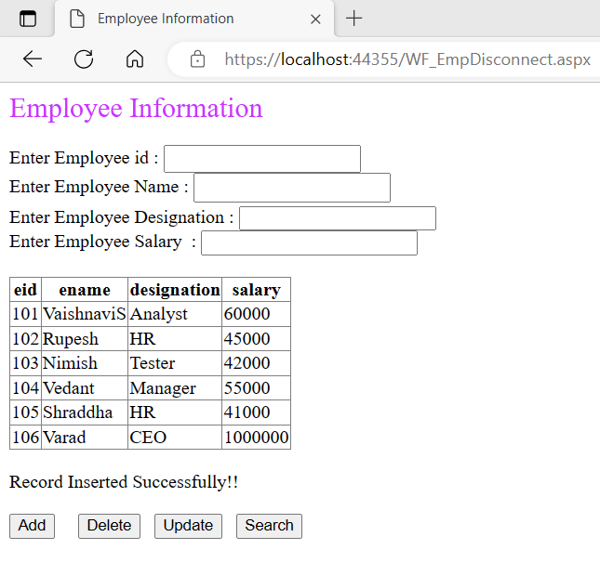**OUTPUT :**

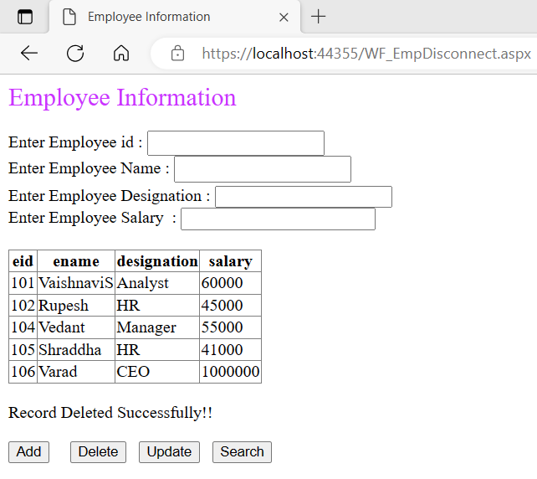

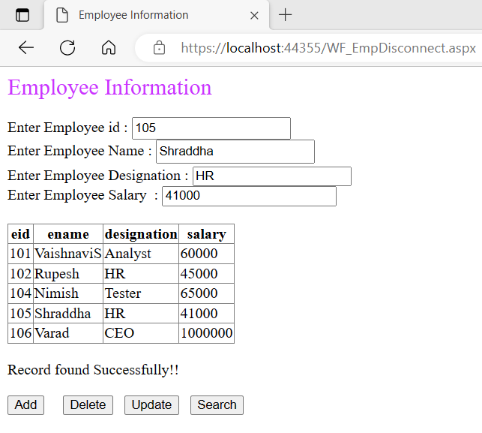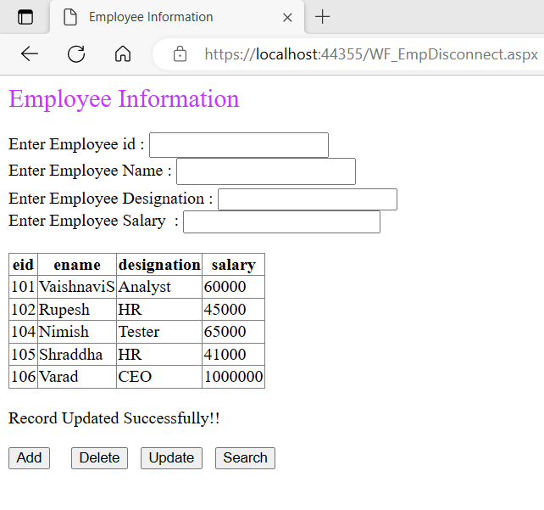

**Que.3. Create stored procedures to add and search employee information from emp_info table and design asp.net web form to call both procedures using connected architecture.**

**Ans:**

* **Code –**

**WF_ConStoreProcEmp.aspx**

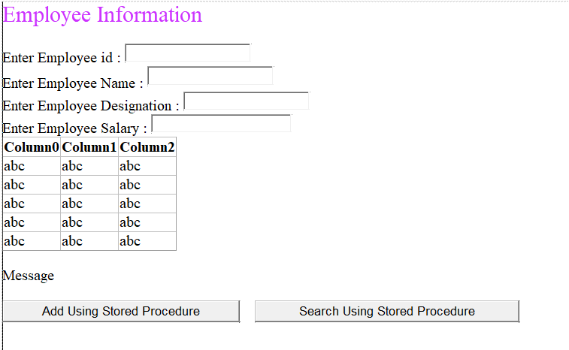

<%@ Page Language="C#" AutoEventWireup="true" CodeBehind="WF_ConStoreProcEmp.aspx.cs" Inherits="PracticalNo03.WF_ConStoreProcEmp" %>

<!DOCTYPE html>

<html xmlns="http://www.w3.org/1999/xhtml">

<head runat="server">

<title></title>

</head>

<body>

<form id="form1" runat="server">

<div style="height: 469px">

<asp:Label ID="Label1" runat="server" Text="Employee Information" Font-Size="X-Large" ForeColor="#CC33FF"></asp:Label>

<br />

<br />

<asp:Label ID="Label2" runat="server" Text="Enter Employee id : "></asp:Label>

<asp:TextBox ID="txtEid" runat="server" Height="19px"></asp:TextBox>

<br />

<asp:Label ID="Label3" runat="server" Text="Enter Employee Name : "></asp:Label>

<asp:TextBox ID="txtEname" runat="server" style="margin-bottom: 3px" Height="20px"></asp:TextBox>

<br />

<asp:Label ID="Label4" runat="server" Text="Enter Employee Designation : "></asp:Label>

<asp:TextBox ID="txtDesignation" runat="server"></asp:TextBox>

<br />

<asp:Label ID="Label5" runat="server" Text="Enter Employee Salary"></asp:Label>

&nbsp;:

<asp:TextBox ID="txtSalary" runat="server" Width="179px"></asp:TextBox>

<br />

<asp:GridView ID="gvEmpDetails" runat="server">

</asp:GridView>

<br />

<asp:Label ID="lblMessage" runat="server" Text="Message"></asp:Label>

<br />

<br />

<asp:Button ID="btnAddSP" runat="server" Text="Add Using Stored Procedure" OnClick="btnAddSP_Click" />

&nbsp;&nbsp;&nbsp;

<asp:Button ID="btnSearchSP" runat="server" Text="Search Using Stored Procedure" OnClick="btnSearchSP_Click" />

&nbsp;

</div>

</form>

</body>

</html>

**WF_ConStoreProcEmp.aspx.cs**

using System;

using System.Collections.Generic;

using System.Linq;

using System.Web;

using System.Web.UI;

using System.Web.UI.WebControls;

using System.Configuration;

using System.Data;

using System.Data.SqlClient;

namespace PracticalNo03

{

public partial class WF_ConStoreProcEmp : System.Web.UI.Page

{

static string conStr = ConfigurationManager.ConnectionStrings["empConString"].ToString();

SqlConnection conn = null;

SqlCommand cmd = null;

SqlDataReader dr = null;

DataTable dt = null;

public void clearTextBox()

{

txtEid.Text = " ";

txtEname.Text = " ";

txtDesignation.Text = " ";

txtSalary.Text = " ";

}

public void showData()

{

try

{

cmd = new SqlCommand("SELECT * FROM emp", conn);

if (conn.State == ConnectionState.Closed)

{

conn.Open();

}

dt = new DataTable();

dr = cmd.ExecuteReader();

dt.Load(dr);

gvEmpDetails.DataSource = dt;

gvEmpDetails.DataBind();

}

catch (Exception ex)

{

lblMessage.Text = "Exception " + ex.Message;

}

finally

{

conn.Close();

}

}

protected void Page_Load(object sender, EventArgs e)

{

conn = new SqlConnection(conStr);

showData();

}

protected void btnAddSP_Click(object sender, EventArgs e)

{

try

{

cmd = new SqlCommand();

if (conn.State == ConnectionState.Closed)

{

conn.Open();

}

cmd.Connection = conn;

cmd.CommandType = CommandType.StoredProcedure;

cmd.CommandText = "insertEmpData";

cmd.Parameters.Add(new SqlParameter("@eid", SqlDbType.TinyInt)).Value = Convert.ToInt16(txtEid.Text);

cmd.Parameters.Add(new SqlParameter("@ename", SqlDbType.NVarChar)).Value = txtEname.Text;

cmd.Parameters.Add(new SqlParameter("@designation", SqlDbType.NVarChar)).Value = txtDesignation.Text;

cmd.Parameters.Add(new SqlParameter("@salary", SqlDbType.Int)).Value = Convert.ToInt64(txtSalary.Text);

int r = cmd.ExecuteNonQuery();

if (r != 0)

{

lblMessage.Text = "Record Inserted Successfully!!";

}

else

{

lblMessage.Text = "Record not Inserted!!";

}

}

catch (Exception ex)

{

lblMessage.Text = "Exception" + ex.Message;

}

finally

{

conn.Close();

clearTextBox();

showData();

}

}

protected void btnSearchSP_Click(object sender, EventArgs e)

{

try

{

cmd = new SqlCommand();

if (conn.State == ConnectionState.Closed)

{

conn.Open();

}

cmd.Connection = conn;

cmd.CommandType = CommandType.StoredProcedure;

cmd.CommandText = "searchEmpData";

cmd.Parameters.Add(new SqlParameter("@eid", SqlDbType.TinyInt)).Value = Convert.ToInt16(txtEid.Text);

dr = cmd.ExecuteReader();

if (dr.HasRows)

{

lblMessage.Text = "Record found Successfully!!";

while (dr.Read())

{

clearTextBox();

txtEid.Text = dr["eid"].ToString();

txtEname.Text = dr["ename"].ToString();

txtDesignation.Text = dr["designation"].ToString();

txtSalary.Text = dr["salary"].ToString();

}

}

else

{

lblMessage.Text = "Record not found!!";

}

}

catch (Exception ex)

{

lblMessage.Text = "Exception" + ex.Message;

}

finally

{

conn.Close();

showData();

}

}

}

}

* **OUTPUT :**

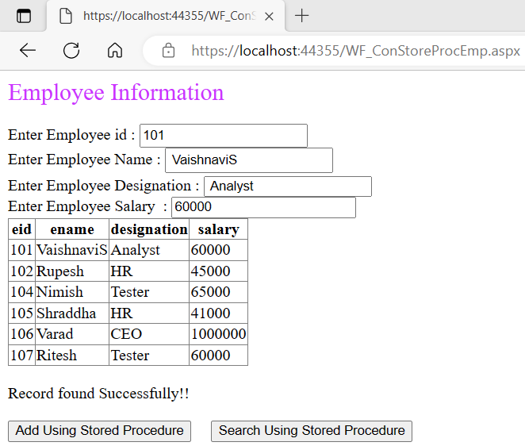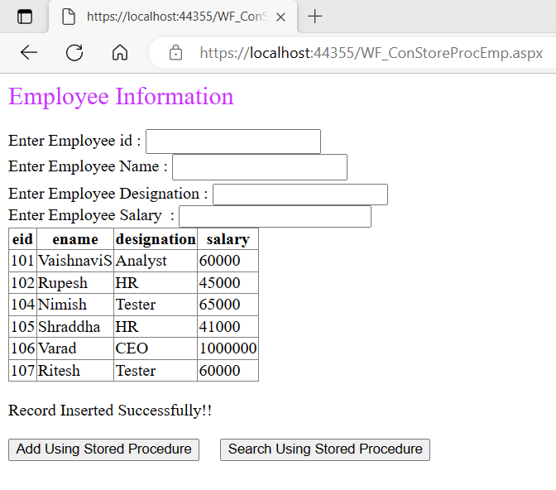

**Que.4. Design asp.net web application to demonstrate DataList, DetailsView, FormView, GridView, ListView and Repeater Data Bound Controls. (Use ProductDetails table).**

**Ans:**

* **Code –**

**WF_DataBoundControls.aspx**

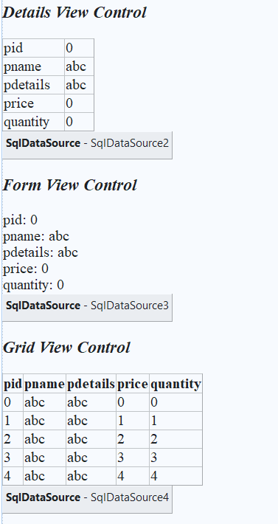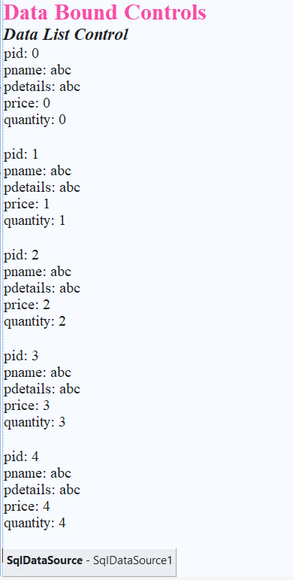

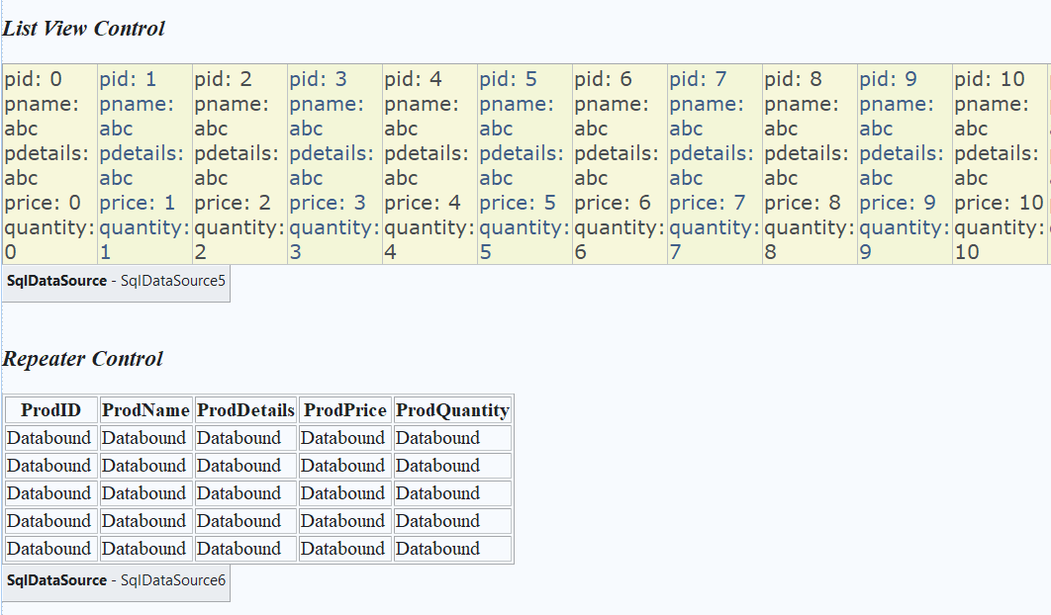

<%@ Page Language="C#" AutoEventWireup="true" CodeBehind="WF_DataBoundControls.aspx.cs" Inherits="PracticalNo03.WF_DataBoundControls" %>

<!DOCTYPE html>

<html xmlns="http://www.w3.org/1999/xhtml">

<head runat="server">

<title>Data Bound Controls</title>

<style type="text/css">

.TableCSS

{

border-style:double;

background-color:white;

text-align:center;

margin-bottom: 0px;

}

.TableHeader

{

background-color:darkgrey;

color:black;

font-size:medium;

font-family:'Gill Sans', 'Gill Sans MT', Calibri, 'Trebuchet MS', sans-serif;

}

.TableData

{

background-color:gainsboro;

color:black;

font-family:Calibri;

font-size:medium;

font-weight:bold;

}

</style>

</head>

<body>

<form id="form1" runat="server">

<div>

<asp:Label ID="Label1" runat="server" Font-Bold="True" Font-Size="X-Large" ForeColor="#FF3399" Text="Data Bound Controls"></asp:Label>

<br />

<asp:Label ID="Label2" runat="server" Font-Bold="True" Font-Italic="True" Font-Size="Large" Text="Data List Control"></asp:Label>

<br />

<asp:DataList ID="DataList1" runat="server" DataKeyField="pid" DataSourceID="SqlDataSource1">

<ItemTemplate>

pid:

<asp:Label ID="pidLabel" runat="server" Text='<%# Eval("pid") %>' />

<br />

pname:

<asp:Label ID="pnameLabel" runat="server" Text='<%# Eval("pname") %>' />

<br />

pdetails:

<asp:Label ID="pdetailsLabel" runat="server" Text='<%# Eval("pdetails") %>' />

<br />

price:

<asp:Label ID="priceLabel" runat="server" Text='<%# Eval("price") %>' />

<br />

quantity:

<asp:Label ID="quantityLabel" runat="server" Text='<%# Eval("quantity") %>' />

<br />

<br />

</ItemTemplate>

</asp:DataList>

<asp:SqlDataSource ID="SqlDataSource1" runat="server" ConnectionString="<%$ ConnectionStrings:prodConString %>" SelectCommand="SELECT * FROM [productDetails]"></asp:SqlDataSource>

<br />

<asp:Label ID="Label3" runat="server" Font-Bold="True" Font-Italic="True" Font-Size="Large" Text="Details View Control"></asp:Label>

<br />

<br />

<asp:DetailsView ID="DetailsView1" runat="server" AutoGenerateRows="False" DataKeyNames="pid" DataSourceID="SqlDataSource2" Height="50px" Width="125px">

<Fields>

<asp:BoundField DataField="pid" HeaderText="pid" ReadOnly="True" SortExpression="pid" />

<asp:BoundField DataField="pname" HeaderText="pname" SortExpression="pname" />

<asp:BoundField DataField="pdetails" HeaderText="pdetails" SortExpression="pdetails" />

<asp:BoundField DataField="price" HeaderText="price" SortExpression="price" />

<asp:BoundField DataField="quantity" HeaderText="quantity" SortExpression="quantity" />

</Fields>

</asp:DetailsView>

<asp:SqlDataSource ID="SqlDataSource2" runat="server" ConnectionString="<%$ ConnectionStrings:prodConString %>" SelectCommand="SELECT * FROM [productDetails]"></asp:SqlDataSource>

<br />

<asp:Label ID="Label4" runat="server" Font-Bold="True" Font-Italic="True" Font-Size="Large" Text="Form View Control"></asp:Label>

<br />

<br />

<asp:FormView ID="FormView1" runat="server" DataKeyNames="pid" DataSourceID="SqlDataSource3">

<EditItemTemplate>

pid:

<asp:Label ID="pidLabel1" runat="server" Text='<%# Eval("pid") %>' />

<br />

pname:

<asp:TextBox ID="pnameTextBox" runat="server" Text='<%# Bind("pname") %>' />

<br />

pdetails:

<asp:TextBox ID="pdetailsTextBox" runat="server" Text='<%# Bind("pdetails") %>' />

<br />

price:

<asp:TextBox ID="priceTextBox" runat="server" Text='<%# Bind("price") %>' />

<br />

quantity:

<asp:TextBox ID="quantityTextBox" runat="server" Text='<%# Bind("quantity") %>' />

<br />

<asp:LinkButton ID="UpdateButton" runat="server" CausesValidation="True" CommandName="Update" Text="Update" />

&nbsp;<asp:LinkButton ID="UpdateCancelButton" runat="server" CausesValidation="False" CommandName="Cancel" Text="Cancel" />

</EditItemTemplate>

<InsertItemTemplate>

pid:

<asp:TextBox ID="pidTextBox" runat="server" Text='<%# Bind("pid") %>' />

<br />

pname:

<asp:TextBox ID="pnameTextBox" runat="server" Text='<%# Bind("pname") %>' />

<br />

pdetails:

<asp:TextBox ID="pdetailsTextBox" runat="server" Text='<%# Bind("pdetails") %>' />

<br />

price:

<asp:TextBox ID="priceTextBox" runat="server" Text='<%# Bind("price") %>' />

<br />

quantity:

<asp:TextBox ID="quantityTextBox" runat="server" Text='<%# Bind("quantity") %>' />

<br />

<asp:LinkButton ID="InsertButton" runat="server" CausesValidation="True" CommandName="Insert" Text="Insert" />

&nbsp;<asp:LinkButton ID="InsertCancelButton" runat="server" CausesValidation="False" CommandName="Cancel" Text="Cancel" />

</InsertItemTemplate>

<ItemTemplate>

pid:

<asp:Label ID="pidLabel" runat="server" Text='<%# Eval("pid") %>' />

<br />

pname:

<asp:Label ID="pnameLabel" runat="server" Text='<%# Bind("pname") %>' />

<br />

pdetails:

<asp:Label ID="pdetailsLabel" runat="server" Text='<%# Bind("pdetails") %>' />

<br />

price:

<asp:Label ID="priceLabel" runat="server" Text='<%# Bind("price") %>' />

<br />

quantity:

<asp:Label ID="quantityLabel" runat="server" Text='<%# Bind("quantity") %>' />

<br />

</ItemTemplate>

</asp:FormView>

<asp:SqlDataSource ID="SqlDataSource3" runat="server" ConnectionString="<%$ ConnectionStrings:prodConString %>" SelectCommand="SELECT * FROM [productDetails]"></asp:SqlDataSource>

<br />

<asp:Label ID="Label5" runat="server" Font-Bold="True" Font-Italic="True" Font-Size="Large" Text="Grid View Control"></asp:Label>

<br />

<br />

<asp:GridView ID="GridView1" runat="server" AutoGenerateColumns="False" DataKeyNames="pid" DataSourceID="SqlDataSource4">

<Columns>

<asp:BoundField DataField="pid" HeaderText="pid" ReadOnly="True" SortExpression="pid" />

<asp:BoundField DataField="pname" HeaderText="pname" SortExpression="pname" />

<asp:BoundField DataField="pdetails" HeaderText="pdetails" SortExpression="pdetails" />

<asp:BoundField DataField="price" HeaderText="price" SortExpression="price" />

<asp:BoundField DataField="quantity" HeaderText="quantity" SortExpression="quantity" />

</Columns>

</asp:GridView>

<asp:SqlDataSource ID="SqlDataSource4" runat="server" ConnectionString="<%$ ConnectionStrings:prodConString %>" SelectCommand="SELECT * FROM [productDetails]"></asp:SqlDataSource>

<br />

<br />

<asp:Label ID="Label6" runat="server" Font-Bold="True" Font-Italic="True" Font-Size="Large" Text="List View Control"></asp:Label>

<br />

<br />

<asp:ListView ID="ListView1" runat="server" DataKeyNames="pid" DataSourceID="SqlDataSource5">

<AlternatingItemTemplate>

<td runat="server" style="background-color:#FAFAD2; color: #284775;">pid:

<asp:Label ID="pidLabel" runat="server" Text='<%# Eval("pid") %>' />

<br />

pname:

<asp:Label ID="pnameLabel" runat="server" Text='<%# Eval("pname") %>' />

<br />

pdetails:

<asp:Label ID="pdetailsLabel" runat="server" Text='<%# Eval("pdetails") %>' />

<br />

price:

<asp:Label ID="priceLabel" runat="server" Text='<%# Eval("price") %>' />

<br />

quantity:

<asp:Label ID="quantityLabel" runat="server" Text='<%# Eval("quantity") %>' />

<br />

</td>

</AlternatingItemTemplate>

<EditItemTemplate>

<td runat="server" style="background-color:#FFCC66; color: #000080;">pid:

<asp:Label ID="pidLabel1" runat="server" Text='<%# Eval("pid") %>' />

<br />

pname:

<asp:TextBox ID="pnameTextBox" runat="server" Text='<%# Bind("pname") %>' />

<br />

pdetails:

<asp:TextBox ID="pdetailsTextBox" runat="server" Text='<%# Bind("pdetails") %>' />

<br />

price:

<asp:TextBox ID="priceTextBox" runat="server" Text='<%# Bind("price") %>' />

<br />

quantity:

<asp:TextBox ID="quantityTextBox" runat="server" Text='<%# Bind("quantity") %>' />

<br />

<asp:Button ID="UpdateButton" runat="server" CommandName="Update" Text="Update" />

<asp:Button ID="CancelButton" runat="server" CommandName="Cancel" Text="Cancel" />

</td>

</EditItemTemplate>

<EmptyDataTemplate>

<table style="background-color: #FFFFFF;border-collapse: collapse;border-color: #999999;border-style:none;border-width:1px;">

<tr>

<td>No data was returned.</td>

</tr>

</table>

</EmptyDataTemplate>

<InsertItemTemplate>

<td runat="server" style="">pid:

<asp:TextBox ID="pidTextBox" runat="server" Text='<%# Bind("pid") %>' />

<br />pname:

<asp:TextBox ID="pnameTextBox" runat="server" Text='<%# Bind("pname") %>' />

<br />pdetails:

<asp:TextBox ID="pdetailsTextBox" runat="server" Text='<%# Bind("pdetails") %>' />

<br />price:

<asp:TextBox ID="priceTextBox" runat="server" Text='<%# Bind("price") %>' />

<br />quantity:

<asp:TextBox ID="quantityTextBox" runat="server" Text='<%# Bind("quantity") %>' />

<br />

<asp:Button ID="InsertButton" runat="server" CommandName="Insert" Text="Insert" />

<asp:Button ID="CancelButton" runat="server" CommandName="Cancel" Text="Clear" />

</td>

</InsertItemTemplate>

<ItemTemplate>

<td runat="server" style="background-color:#FFFBD6; color: #333333;">pid:

<asp:Label ID="pidLabel" runat="server" Text='<%# Eval("pid") %>' />

<br />

pname:

<asp:Label ID="pnameLabel" runat="server" Text='<%# Eval("pname") %>' />

<br />

pdetails:

<asp:Label ID="pdetailsLabel" runat="server" Text='<%# Eval("pdetails") %>' />

<br />

price:

<asp:Label ID="priceLabel" runat="server" Text='<%# Eval("price") %>' />

<br />

quantity:

<asp:Label ID="quantityLabel" runat="server" Text='<%# Eval("quantity") %>' />

<br />

</td>

</ItemTemplate>

<LayoutTemplate>

<table runat="server" border="1" style="background-color: #FFFFFF;border-collapse: collapse;border-color: #999999;border-style:none;border-width:1px;font-family: Verdana, Arial, Helvetica, sans-serif;">

<tr id="itemPlaceholderContainer" runat="server">

<td id="itemPlaceholder" runat="server"></td>

</tr>

</table>

<div style="text-align: center;background-color: #FFCC66; font-family: Verdana, Arial, Helvetica, sans-serif;color: #333333;">

</div>

</LayoutTemplate>

<SelectedItemTemplate>

<td runat="server" style="background-color:#FFCC66; font-weight: bold;color: #000080;">pid:

<asp:Label ID="pidLabel" runat="server" Text='<%# Eval("pid") %>' />

<br />

pname:

<asp:Label ID="pnameLabel" runat="server" Text='<%# Eval("pname") %>' />

<br />

pdetails:

<asp:Label ID="pdetailsLabel" runat="server" Text='<%# Eval("pdetails") %>' />

<br />

price:

<asp:Label ID="priceLabel" runat="server" Text='<%# Eval("price") %>' />

<br />

quantity:

<asp:Label ID="quantityLabel" runat="server" Text='<%# Eval("quantity") %>' />

<br />

</td>

</SelectedItemTemplate>

</asp:ListView>

<asp:SqlDataSource ID="SqlDataSource5" runat="server" ConnectionString="<%$ ConnectionStrings:prodConString %>" SelectCommand="SELECT * FROM [productDetails]"></asp:SqlDataSource>

<br />

<br />

<asp:Label ID="Label12" runat="server" Font-Bold="True" Font-Italic="True" Font-Size="Large" Text="Repeater Control"></asp:Label>

<br />

<br />

<asp:Repeater ID="Repeater1" runat="server" DataSourceID="SqlDataSource6">

<HeaderTemplate>

<table border="1">

<tr>

<th scope="col" style="width:90px">

ProdID

</th>

<th scope="col" style="width:90px">

ProdName

</th>

<th scope="col" style="width:90px">

ProdDetails

</th>

<th scope="col" style="width:90px">

ProdPrice

</th>

<th scope="col" style="width:90px">

ProdQuantity

</th>

</tr>

<br />

</HeaderTemplate>

<ItemTemplate>

<tr>

<td> <asp:Label ID="pidLabel" runat="server" Text='<%# Eval("pid") %>' /></td>

<td><asp:Label ID="pnameLabel" runat="server" Text='<%# Eval("pname") %>' /></td>

<td><asp:Label ID="pdetailsLabel" runat="server" Text='<%# Eval("pdetails") %>' /></td>

<td><asp:Label ID="priceLabel" runat="server" Text='<%# Eval("price") %>' /></td>

<td><asp:Label ID="quantityLabel" runat="server" Text='<%# Eval("quantity") %>' /></td>

</tr>

</ItemTemplate>

<FooterTemplate>

</table>

</FooterTemplate>

</asp:Repeater >

<asp:SqlDataSource ID="SqlDataSource6" runat="server" ConnectionString="<%$ ConnectionStrings:prodConString %>" SelectCommand="SELECT * FROM [productDetails]"></asp:SqlDataSource>

<br />

<br />

</div>

</form>

</body>

</html>

* **OUTPUT :**

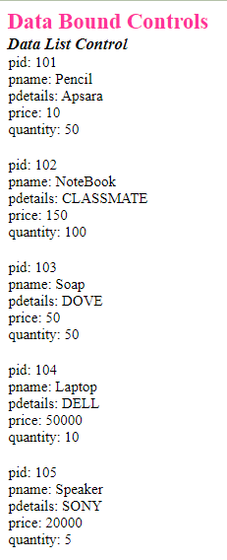

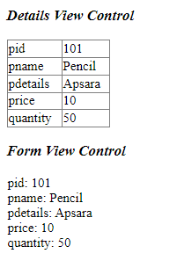

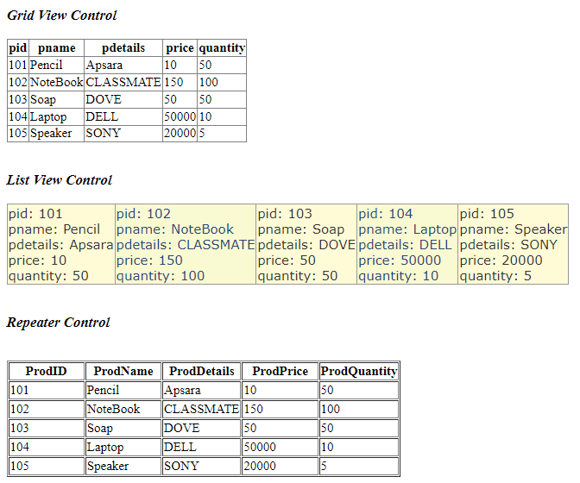

**Que.5. Design asp.net web form to search all words with length is less than five characters from string array using LINQ.**

**Ans:**

* **Code –**

**WF_LINQ.aspx**

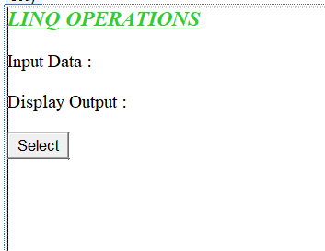

<%@ Page Language="C#" AutoEventWireup="true" CodeBehind="WF_LINQ.aspx.cs" Inherits="PracticalNo03.WF_LINQ" %>

<!DOCTYPE html>

<html xmlns="http://www.w3.org/1999/xhtml">

<head runat="server">

<title></title>

</head>

<body>

<form id="form1" runat="server">

<div style="height: 268px">

<asp:Label ID="Label1" runat="server" Font-Bold="True" Font-Italic="True" Font-Size="Large" Font-Underline="True" ForeColor="#33CC33" Text="LINQ OPERATIONS"></asp:Label>

<br />

<br />

<asp:Label ID="lblInputData" runat="server" Text="Input Data : "></asp:Label>

<br />

<br />

<asp:Label ID="lblAns" runat="server" Text="Display Output : "></asp:Label>

<br />

<br />

<asp:Button ID="btnSelect" runat="server" OnClick="btnSelect_Click" Text="Select" />

</div>

</form>

</body>

</html>

**WF_LINQ.aspx.cs**

using System;

using System.Collections.Generic;

using System.Linq;

using System.Web;

using System.Web.UI;

using System.Web.UI.WebControls;

namespace PracticalNo03

{

public partial class WF_LINQ : System.Web.UI.Page

{

protected void Page_Load(object sender, EventArgs e)

{

}

protected void btnSelect_Click(object sender, EventArgs e)

{

//Specify the data Source

string[] my_words = { "hello", "wonderful", "LINQ", "beautiful", "world" };

foreach(string s in my_words)

{

lblInputData.Text = lblInputData.Text + " " + s;

}

//define the query expression.//Get only shorts word

var shortWords = from word in my_words where word.Length <= 5 select word;

//Execute the query.//Print each word out

foreach(var word in shortWords)

{

lblAns.Text = lblAns.Text + " " + word;

}

}

}

}

* **OUTPUT :**

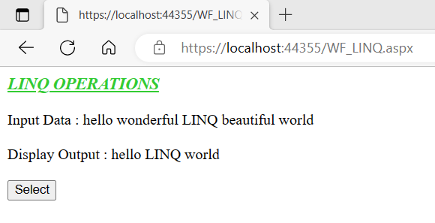

**Que.6. Design asp.net web form to find odd numbers from integer Array using LINQ.**

**Ans:**

* **Code –**

**WF_OddNum_LINQ.aspx**

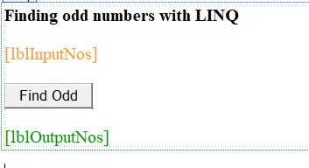

<%@ Page Language="C#" AutoEventWireup="true" CodeBehind="WF_OddNum_LINQ.aspx.cs" Inherits="PracticalNo03.WF_OddNum_LINQ" %>

<!DOCTYPE html>

<html xmlns="http://www.w3.org/1999/xhtml">

<head runat="server">

<title>Odd Numbers</title>

</head>

<body>

<form id="form1" runat="server">

<div>

<asp:Label ID="lblHeading" runat="server" Font-Bold="True" Font-Size="Medium" Text="Finding odd numbers with LINQ"></asp:Label>

<br />

<br />

<asp:Label ID="lblInputNos" runat="server" ForeColor="#FF9933"></asp:Label>

<br />

<br />

<asp:Button ID="btnFindOdd" runat="server" OnClick="btnFindOdd_click" Text="Find Odd" />

<br />

<br />

<asp:Label ID="lblOutputNos" runat="server" ForeColor="#009900"></asp:Label>

</div>

</form>

</body>

</html>

**WF_OddNum_LINQ.aspx.cs**

using System;

using System.Collections.Generic;

using System.Linq;

using System.Web;

using System.Web.UI;

using System.Web.UI.WebControls;

namespace PracticalNo03

{

public partial class WF_OddNum_LINQ : System.Web.UI.Page

{

int[] numbers = new int[7] { 1, 2, 3, 4, 5, 6, 7 };

protected void Page_Load(object sender, EventArgs e)

{

lblInputNos.Text = "Input Numbers : ";

foreach (int n in numbers)

{

lblInputNos.Text = lblInputNos.Text + " " + n;

}

}

protected void btnFindOdd_click(object sender, EventArgs e)

{

IEnumerable<int> numQuery = from num in numbers

where (num % 2) != 0

select num;

lblOutputNos.Text = "Odd Numbers: ";

foreach (int n in numQuery)

{ lblOutputNos.Text = lblOutputNos.Text + " " + n.ToString(); }

}

}

}

* **OUTPUT :**

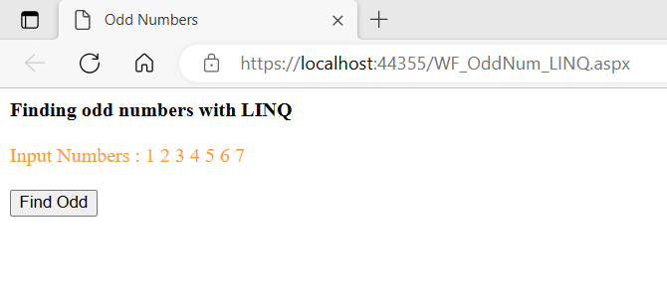

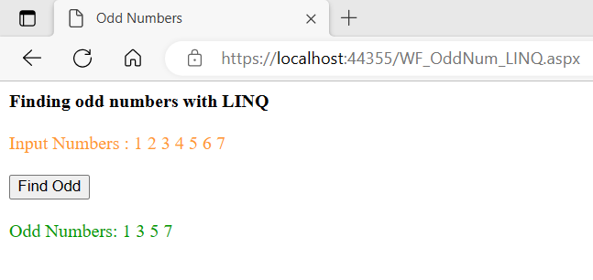

**Que.7. Design asp.net web application to perform add, update, delete and search operations on emp_info Table using LINQ to SQL.**

**Ans:**

* **Code –**

**WF_LINQ_DB.aspx**

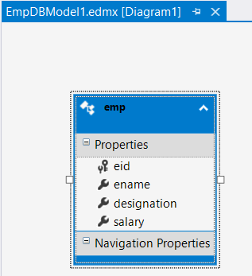

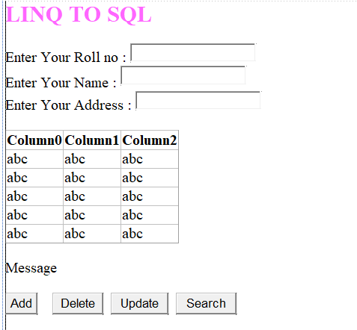

<%@ Page Language="C#" AutoEventWireup="true" CodeBehind="WF_LINQ_DB.aspx.cs" Inherits="PracticalNo03.WF_LINQ_DB" %>

<!DOCTYPE html>

<html xmlns="http://www.w3.org/1999/xhtml">

<head runat="server">

<title></title>

</head>

<body>

<form id="form1" runat="server">

<div>

<asp:Label ID="Label1" runat="server" Font-Bold="True" Font-Size="X-Large" ForeColor="#FF66FF" Text=" LINQ TO SQL"></asp:Label>

<br />

<br />

<asp:Label ID="Label2" runat="server" Text="Enter Your Roll no : "></asp:Label>

<asp:TextBox ID="txtRollNo" runat="server" Height="19px"></asp:TextBox>

<br />

<asp:Label ID="Label3" runat="server" Text="Enter Your Name : "></asp:Label>

<asp:TextBox ID="txtName" runat="server" style="margin-bottom: 3px" Height="20px"></asp:TextBox>

<br />

<asp:Label ID="Label4" runat="server" Text="Enter Your Address : "></asp:Label>

<asp:TextBox ID="txtAddress" runat="server"></asp:TextBox>

<br />

<br />

<asp:GridView ID="gvStudDetails" runat="server">

</asp:GridView>

<br />

<asp:Label ID="lblMessage" runat="server" Text="Message"></asp:Label>

<br />

<br />

<asp:Button ID="btnAdd" runat="server" Text="Add" OnClick="btnAdd_Click" />

&nbsp;&nbsp;&nbsp;

<asp:Button ID="btnDelete" runat="server" Text="Delete" OnClick="btnDelete_Click" />

&nbsp;

<asp:Button ID="btnUpdate" runat="server" Text="Update" OnClick="btnUpdate_Click" />

&nbsp;

<asp:Button ID="btnSearch" runat="server" Text="Search" OnClick="btnSearch_Click" />

&nbsp;

<br />

<br />

</div>

</form>

</body>

</html>

**WF_LINQ_DB.aspx.cs**

using System;

using System.Collections.Generic;

using System.Linq;

using System.Web;

using System.Web.UI;

using System.Web.UI.WebControls;

namespace PracticalNo03

{

public partial class WF_LINQ_DB : System.Web.UI.Page

{

DataClasses1DataContext dc = new DataClasses1DataContext();

public void clearTextBox()

{

txtRollNo.Text = " ";

txtName.Text = " ";

txtAddress.Text = " ";

}

public void showData()

{

try

{

var q = from a in dc.GetTable<stud>() select a;

gvStudDetails.DataSource = q;

gvStudDetails.DataBind();

}

catch(Exception ex)

{

lblMessage.Text = "Exception caught!! " + ex.Message;

}

}

protected void Page_Load(object sender, EventArgs e)

{

showData();

}

protected void btnAdd_Click(object sender, EventArgs e)

{

try

{

stud objAdd = new stud();

objAdd.rollno = Convert.ToByte(txtRollNo.Text);

objAdd.name = Convert.ToString(txtName.Text);

objAdd.address = Convert.ToString(txtAddress.Text);

dc.studs.InsertOnSubmit(objAdd);

dc.SubmitChanges();

lblMessage.Text = "Record Inserted Successfully!!";

}

catch(Exception ex)

{

lblMessage.Text = "Exception caught!! " + ex.Message;

}

finally

{

clearTextBox();

showData();

}

}

protected void btnDelete_Click(object sender, EventArgs e)

{

try

{

stud objDel = dc.studs.Single(stud => stud.rollno == Convert.ToInt16(txtRollNo.Text));

dc.studs.DeleteOnSubmit(objDel);

dc.SubmitChanges();

lblMessage.Text = "Record Delete Successfully!!";

}

catch (Exception ex)

{

lblMessage.Text = "Exception caught!! " + ex.Message;

}

finally

{

clearTextBox();

showData();

}

}

protected void btnUpdate_Click(object sender, EventArgs e)

{

try

{

stud objUpdate = dc.studs.Single(stud => stud.rollno == Convert.ToInt16(txtRollNo.Text));

//Field which will be update

objUpdate.name = Convert.ToString(txtName.Text);

objUpdate.address = Convert.ToString(txtAddress.Text);

dc.SubmitChanges();

clearTextBox();

lblMessage.Text = "Record Update Successfully!!";

}

catch (Exception ex)

{

lblMessage.Text = "Exception caught!! " + ex.Message;

}

finally

{

showData();

}

}

protected void btnSearch_Click(object sender, EventArgs e)

{

try

{

stud objSearch = dc.studs.Single(stud => stud.rollno == Convert.ToInt16(txtRollNo.Text));

txtRollNo.Text = Convert.ToString(objSearch.rollno);

txtName.Text = objSearch.name;

txtAddress.Text = objSearch.address;

lblMessage.Text = "Record Found Successfully";

}

catch (Exception ex)

{

lblMessage.Text = "Exception caught!! " + ex.Message;

}

finally

{

showData();

}

}

}

}

* **OUTPUT :**

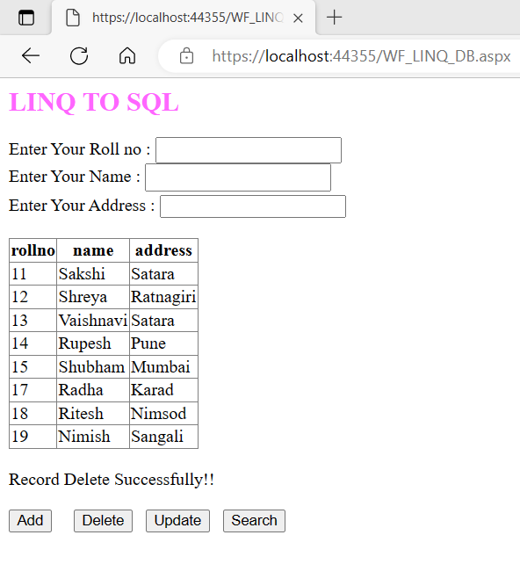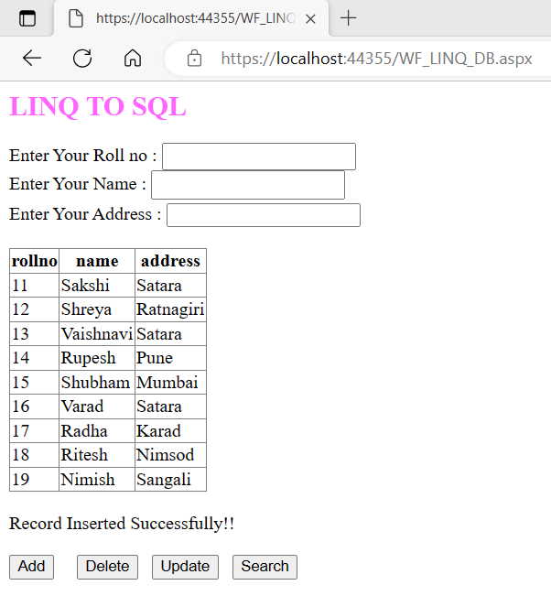

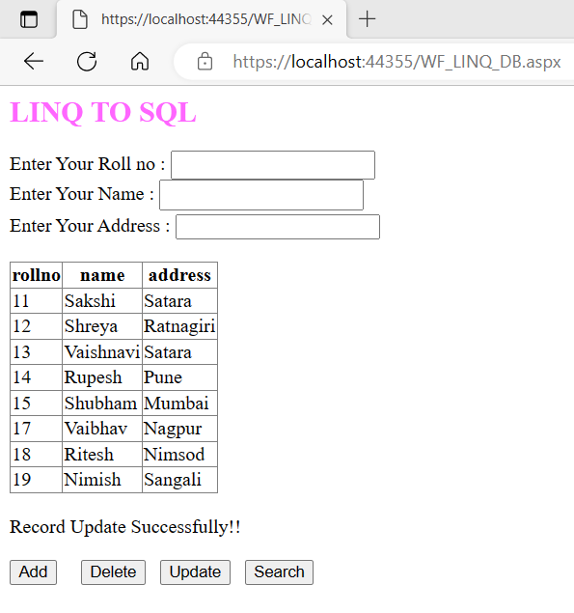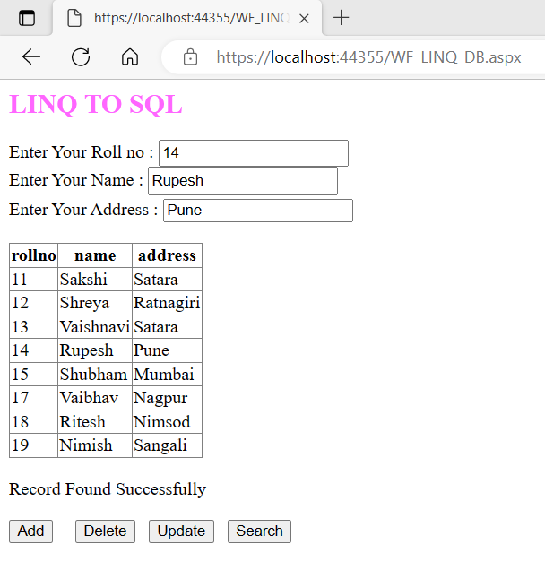

**Que.8. Design asp.net web application to perform add, update, delete and search operations on ProductDetails Table using Entity Framework**.

**Ans:**

* **Code –**

**WF_ProductDetailsEntityFramework.aspx**

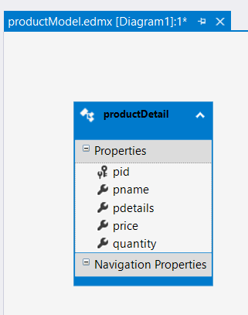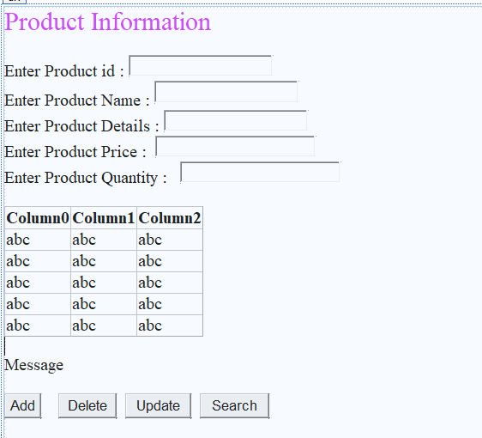

<%@ Page Language="C#" AutoEventWireup="true" CodeBehind="WF_ProductDetailsEntityFramework.aspx.cs" Inherits="PracticalNo03.WF_ProductDetailsEntityFramework" %>

<!DOCTYPE html>

<html xmlns="http://www.w3.org/1999/xhtml">

<head runat="server">

<title>Product Details</title>

</head>

<body>

<form id="form1" runat="server">

<div>

<asp:Label ID="Label1" runat="server" Text="Product Information" Font-Size="X-Large" ForeColor="#CC33FF"></asp:Label>

<br />

<br />

<asp:Label ID="Label2" runat="server" Text="Enter Product id : "></asp:Label>

<asp:TextBox ID="txtPid" runat="server" Height="19px"></asp:TextBox>

<br />

<asp:Label ID="Label3" runat="server" Text="Enter Product Name : "></asp:Label>

<asp:TextBox ID="txtPname" runat="server" style="margin-bottom: 3px" Height="20px"></asp:TextBox>

<br />

<asp:Label ID="Label4" runat="server" Text="Enter Product Details : "></asp:Label>

<asp:TextBox ID="txtDetails" runat="server"></asp:TextBox>

<br />

<asp:Label ID="Label5" runat="server" Text="Enter Product Price : "></asp:Label>

&nbsp;<asp:TextBox ID="txtPrice" runat="server" Width="179px"></asp:TextBox>

<br />

<asp:Label ID="Label6" runat="server" Text="Enter Product Quantity : "></asp:Label>

&nbsp;

<asp:TextBox ID="txtQuantity" runat="server" Width="179px"></asp:TextBox>

<br />

<br />

<asp:GridView ID="gvProductDetails" runat="server">

</asp:GridView>

<br />

<asp:Label ID="lblMessage" runat="server" Text="Message"></asp:Label>

<br />

<br />

<asp:Button ID="btnAdd" runat="server" Text="Add" OnClick="btnAdd_Click" />

&nbsp;&nbsp;&nbsp;

<asp:Button ID="btnDelete" runat="server" Text="Delete" OnClick="btnDelete_Click" />

&nbsp;

<asp:Button ID="btnUpdate" runat="server" Text="Update" OnClick="btnUpdate_Click" />

&nbsp;

<asp:Button ID="btnSearch" runat="server" Text="Search" OnClick="btnSearch_Click" />

&nbsp;

<br />

<br />

</div>

</form>

</body>

</html>

**WF_ProductDetailsEntityFramework.aspx.cs**

using System;

using System.Collections.Generic;

using System.Linq;

using System.Web;

using System.Web.UI;

using System.Web.UI.WebControls;

namespace PracticalNo03

{

public partial class WF_ProductDetailsEntityFramework : System.Web.UI.Page

{

productDBEntities1 p1 = new productDBEntities1();

public void clearTextBox()

{

txtPid.Text = " ";

txtPname.Text = " ";

txtDetails.Text = " ";

txtPrice.Text = " ";

txtQuantity.Text = " ";

}

public void showData()

{

try

{

gvProductDetails.DataSource = p1.productDetails.ToList();

gvProductDetails.DataBind();

}

catch (Exception ex)

{

lblMessage.Text = "Exception Caught!!" + ex.Message;

}

}

protected void Page_Load(object sender, EventArgs e)

{

showData();

}

protected void btnAdd_Click(object sender, EventArgs e)

{

try

{

productDetail productObjAdd = new productDetail();

productObjAdd.pid = (byte)Convert.ToInt32(txtPid.Text);

productObjAdd.pname = txtPname.Text;

productObjAdd.pdetails = txtDetails.Text;

productObjAdd.price = Convert.ToInt32(txtPrice.Text);

productObjAdd.quantity = Convert.ToInt32(txtQuantity.Text);

p1.productDetails.Add(productObjAdd);

p1.SaveChanges();

lblMessage.Text = "Record Added Successfully!!";

showData();

clearTextBox();

}

catch (Exception ex)

{

lblMessage.Text = "Exception Caught!!" + ex.Message;

}

}

protected void btnDelete_Click(object sender, EventArgs e)

{

try

{

productDetail productObjDelete = p1.productDetails.Find(Convert.ToInt32(txtPid.Text));

if (productObjDelete != null)

{

p1.productDetails.Remove(productObjDelete);

p1.SaveChanges();

lblMessage.Text = "Recored Deleted Successfully!!";

showData();

clearTextBox();

}

else

{

lblMessage.Text = "Record Not Found!!";

}

}

catch (Exception ex)

{

lblMessage.Text = "Exception Caught!!" + ex.Message;

}

}

protected void btnUpdate_Click(object sender, EventArgs e)

{

try

{

productDetail productObjUpdate = p1.productDetails.Find(Convert.ToInt32(txtPid.Text));

if (productObjUpdate != null)

{

productObjUpdate.pname = txtPname.Text;

productObjUpdate.pdetails = txtDetails.Text;

productObjUpdate.price = Convert.ToInt32(txtPrice.Text);

productObjUpdate.quantity = Convert.ToInt32(txtQuantity.Text);

p1.SaveChanges();

lblMessage.Text = "Recored Updated Successfully!!";

showData();

clearTextBox();

}

else

{

lblMessage.Text = "Record Not Found!";

}

}

catch (Exception ex)

{

lblMessage.Text = "Exception Caught!!" + ex.Message;

}

}

protected void btnSearch_Click(object sender, EventArgs e)

{

try

{

productDetail productObjSearch = p1.productDetails.Find(Convert.ToInt32(txtPid.Text));

if (productObjSearch != null)

{

txtPid.Text = Convert.ToString(productObjSearch.pid);

txtPname.Text = productObjSearch.pname;

txtDetails.Text = productObjSearch.pdetails;

txtPrice.Text = Convert.ToString(productObjSearch.price);

txtQuantity.Text = Convert.ToString(productObjSearch.quantity);

p1.SaveChanges();

lblMessage.Text = "Recored Found Successfully!!";

showData();

}

else

{

lblMessage.Text = "Record Not Found!";

}

}

catch (Exception ex)

{

lblMessage.Text = "Exception Caught!!" + ex.Message;

}

}

}

}

* 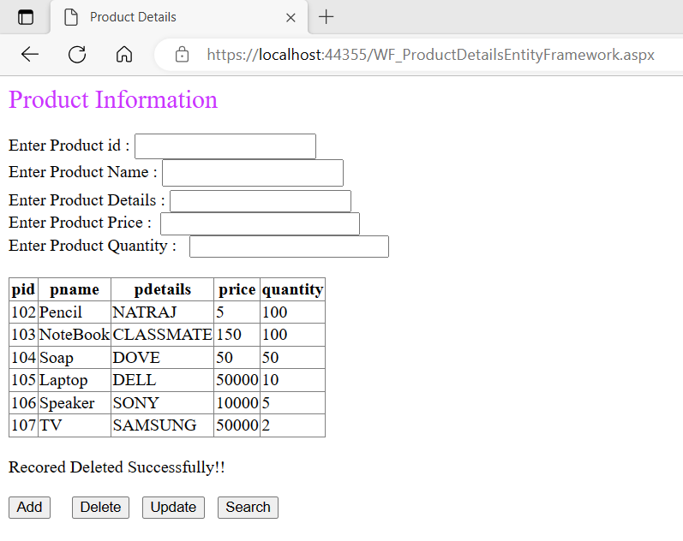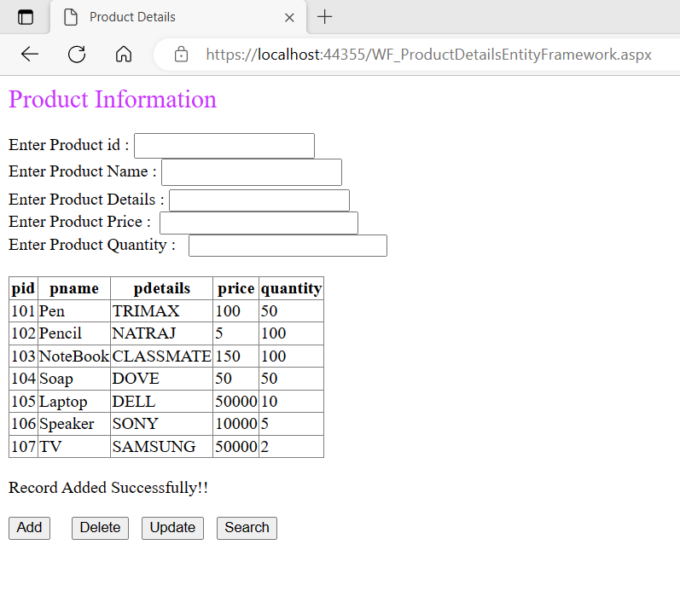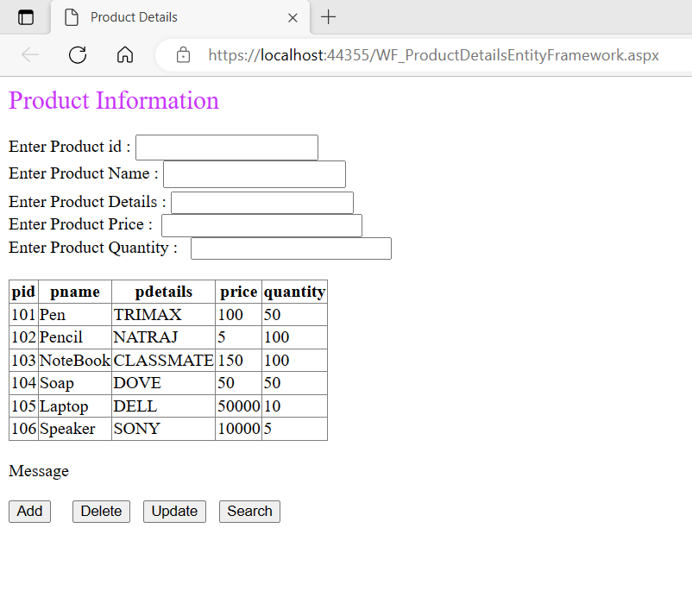**OUTPUT :**

